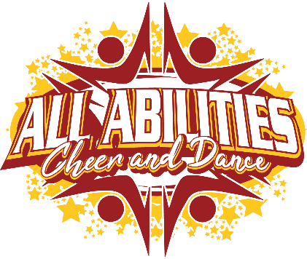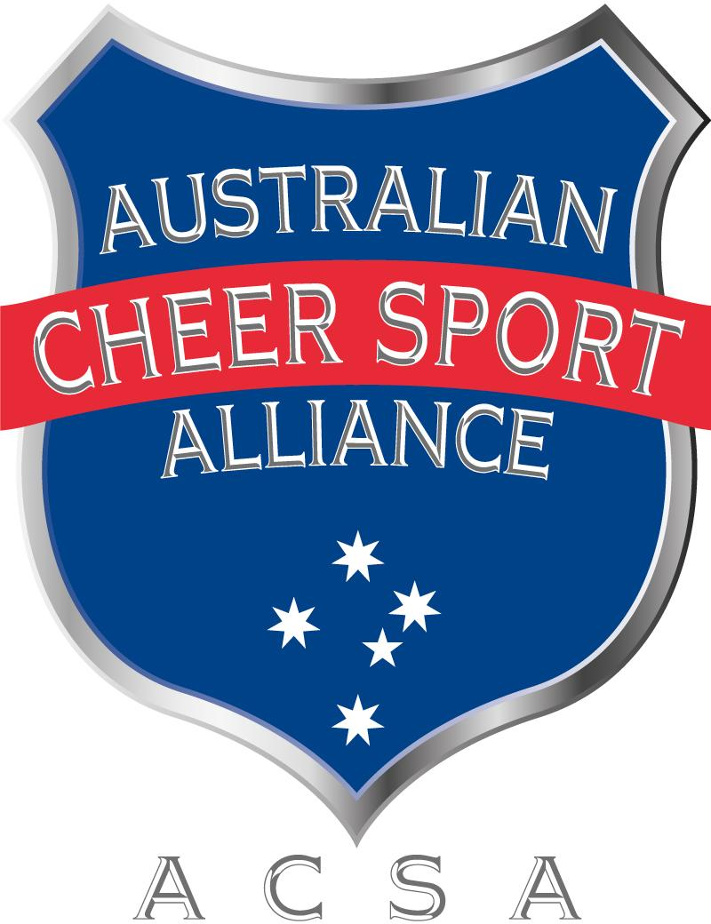

ALL ABILITIES CHEER AND DANCE

Social Media Policy

Date of issue: January 2023
Date of next review: January 2024
Approved by: All Abilities Cheer and Dance, Alana Giaccio, Director
This social media policy has been endorsed by ACSA.
Table of Contents
1. Purpose 2
2. Scope 2
3. Policy Coverage 3
4. Roles and Responsibilities: 3
5. Guidelines 3
6. Policy Breaches 6
7. Reporting a Breach 6
8. Investigation 6
9. Disciplinary Process and Consequences 7
10. Related Policies/References 7

Purpose
Social media is changing the way we communicate and is now integrated into most people’s everyday lives. All Abilities Cheer and Dance (AACD) recognises the importance of electronic communications and social media as it is easier to share ideas, information, and experiences, however it is also important to protect the privacy, confidentiality, and interests of all involved with AACD and it is critical to have policy guidance where minors and vulnerable people are involved.

This policy has been developed to inform our community about using social media, so people feel enabled to participate, while being mindful of their responsibilities and obligations. This policy provides practical guidance allowing all parties to benefit from the use of social media, while minimising potential risks and protecting those involved.
This policy assists to establish a culture of openness, trust and integrity in all online activities related to Cheer Sport in Australia.

This policy contains AACD guidelines for our community to engage in social media use. It also includes details for breaches of the policy. In circumstances where guidance about social media issues has not been given in this policy, we suggest you use common sense or seek out advice from those who have approved this policy.

These guidelines will be made easily available on AACD’s website.

Scope
Social media refers to any online tools or functions that allow people to communicate and/or share content via the internet.
This social media policy applies to platforms including, but not limited to:
- Social networking sites (e.g. Facebook, Twitter, LinkedIn, Pinterest, etc)
- Video and photo sharing websites or apps (e.g. YouTube, Instagram, TikTok, etc)
- Instant messaging (e.g. SMS, Skype, Snapchat, WhatsApp, Viber, etc)
- Any other online technologies that allow individual users to upload and share content.

Policy Coverage
This policy is applicable to all persons who are using social media platforms with reference to Cheer Sport and involved with AACD, whether they are in a paid or unpaid/voluntary capacity and including:
- Employees, student teachers and volunteers of AACD
- athletes, coaches, officials and other personnel participating in events and activities, including camps and training sessions, held by AACD or sanctioned by ACSA and
- AACD athletes’ family members and any other friends/supporters

NOTE: This policy does not apply to the personal use of social media where it is not related to or there is no reference to Cheer Sport, AACD, or its business, competitions, teams, participants, products, services, events, sponsors, members or reputation. However, any misuse of social media in a manner that does not directly refer to AACD may still be regulated by other policies, rules or regulations of AACD.

Roles and Responsibilities:
All persons involved with AACD, at any level including the athlete’s family or support worker are responsible for the content of their communication. All individuals listed under the policy coverage above have a responsibility to ensure that:
- Communications do not cause damage to AACD, its interests or the reputation of the wider Cheer Sport community
- Information about AACD services and products are accurate
- Inappropriate or unlawful content online relating to AACD in breach of this policy is reported to Miss Alana, Director @ AACD.
- Logos and trademarks are only used with permission from AACD.
- Permission is sought from the relevant parties before creating an official social media account relating to AACD.
As a part of the AACD community you are an extension of our brand and the wider reputation of Cheer Sport in Australia.
As such, the boundaries between when you are representing yourself and when you are representing AACD can often be blurred. This becomes even more of an issue as you increase your profile or position or affiliation with AACD. Therefore, it is important that you always represent both yourself and AACD appropriately online.

Guidelines
You must adhere to the following guidelines when using social media related to AACD or its business, products, competitions, teams, participants, services, events, sponsors, members or reputation. The web is not anonymous, remember, if you are online, you are on the record—much of the content posted online is public and searchable. You should assume that all information posted online can be traced back to you. You are accountable for your actions both on and offline, including the information you post via your personal social media accounts.
- Use common sense
- If you are unsure if the content you wish to share is appropriate, seek advice from others or refrain from sharing to be on the safe side
- Remember when posting that the lines between public, private, personal and professional can be blurred you are a representative of AACD and cheer sport in Australia.

- Honesty
  - Do not say anything that is dishonest, untrue or misleading. Check the source and the facts before uploading or posting anything.
  - AACD recommends erring on the side of caution – if in doubt, do not post or upload.
  - Do not post anonymously, using pseudonyms or false screen names. Use your real name, be clear about who you are and disclose any affiliations, vested interests, endorsements or recommendations.

- Dealing with mistakes
  - If you make an error while posting on social media, be up front about the mistake and address it quickly. If someone accuses you of posting something improper (such as their copyrighted material or a defamatory comment about them), address it promptly and appropriately and if necessary, seek legal advice.

- Discrimination, sexual harassment and bullying
The public in general, and AACD employees and members, reflect a diverse set of customs, values and points of view.
- You must not post any material that is offensive, harassing, discriminatory, embarrassing, intimidating, sexually explicit, bullying, hateful, racist, sexist or otherwise inappropriate.
- When using social media, you should be mindful of AACD communication, values, Anti-Discrimination, Harassment, Bullying and Gender Identity Anti-Discrimination policies.

- Protecting your privacy
  - Be smart about protecting yours and others privacy, particularly keeping in mind applicable child safe standards.
  - Refrain from posting any content online that you would not be happy for the public to see (even if you are posting privately)
  - Be cautious about disclosing personal details and where possible set accounts to limit public access.

- Respect confidentiality and sensitivity
When using social media;
  - you must maintain the privacy of AACD confidential information online. This includes information that is not publicly accessible, widely known, or not expected to be shared outside of AACD
  - it is acceptable to talk about AACD and have a dialogue with your community, but it is not okay to publish AACD’s confidential information. Confidential information includes things such as details about litigation, and unpublished details about us e.g. team, coaching practices, financial information.
  - you should be considerate to others and should not post information when you have been asked not to, or where consent has not been sought and given. You must also remove information about another person if that person asks you to do so.
  - permission should always be sought if the use or publication of information is not incidental, but directly related to an individual. This is particularly relevant to publishing any information regarding minors. In such circumstances, parental or guardian consent is mandatory.
- Gaining permission when publishing a person’s identifiable image
  - You must obtain express permission from an individual to use a direct, clearly identifiable image of that person.
  - You should also refrain from posting any information or photos of a sensitive nature. This could include accidents, incidents or controversial behaviour.
  - In every instance, you need to have consent of the owner of copyright in the image.

- Avoiding controversial issues
  - Within the scope of your authorisation with AACD, if you see misrepresentations made about AACD in the media, you may point that out to Miss Alana, Director @ AACD.
  - Always do so with respect and with the facts. If you speak about others, make sure what you say is based on fact and does not discredit or belittle that party.

- Complying with applicable laws
  - Do not post or link to content that contains illegal or indecent content, including defamatory, vilifying or misleading and deceptive content.
  - Always follow the terms and conditions for any third-party sites in which you participate.
  - You must comply with the laws governing copyright in relation to material owned by others and AACD own copyrights and brands.

- Use of disclaimers
  - Where practical, include a disclaimer stating who you work for or are affiliated with (e.g. member of AACD) and that anything you publish is your personal opinion and that you are not speaking officially.
  - This is good practice and is encouraged, but don't count on it to avoid trouble -– it may not have legal effect.

- Branding and intellectual property of AACD
  - You must not use any of AACD’s intellectual property or imagery on your personal social media without prior approval from Miss Alana, Director @ AACD.
  - AACD’s intellectual property includes but is not limited to trademarks, logos, slogans, imagery which has been posted on AACD official social media sites or website.
  - You must not create either an official or unofficial AACD presence using the organisation’s trademarks or name without prior approval from AACD.
  - You must not imply that you are authorised to speak on behalf of AACD unless you have been given official authorisation to do so by AACD.
  - Where permission has been granted to create or administer an official social media presence for AACD, you must adhere to the AACD Branding Guidelines.
Keep in mind that what you publish is your responsibility, and failure to abide by these guidelines could hinder your affiliation/membership with AACD.
Guidelines for AACD representatives
Owners, coaches and other adult members of AACD are prohibited from having participants joined to or connected through their personal social media accounts or applications, e.g. Facebook, Instagram, Tik Tok, BeReal, SnapChat, etc.
To facilitate communication, AACD may choose to set up private team pages on social media that athletes and parents may join (e.g. friend, follow or like) and coaches can communicate to athletes and parents through that page or site.
AACD will ensure that all electronic communication of any kind between coach and athlete will be non-personal in nature and only used for communicating necessary information related to the team or AACD.
- Personal Social Media Sites
Any adults affiliated with AACD may have a personal social media page or site abiding by the following restrictions
  - May not invite or allow athlete to friend/follow or join a personal social media account/site or similar online community
  - May not private or instant message athletes
  - Must inform parents and athletes that the above is not permitted at AACD
  - It is highly recommended that adults affiliated with AACD make their pages “private” to restrict athlete access
- Reasonable Use
  - Employees/volunteers/contractors of AACD must ensure that personal use of social media does not interfere with work commitments or productivity.

Policy Breaches
Individuals or organisations publishing false or misleading comments about another person or organisation may be liable for defamation.
Breaches of this policy include but are not limited to:
- Posting or sharing material that brings, or risks bringing AACD, its affiliates, its sport, its officials, members or sponsors into disrepute. In this context, bringing a person or organisation into disrepute is to lower the reputation of that person or organisation in the eyes of the ordinary members of the public.
- Using AACD’s name, motto, crest and/or logo in a way that would result in a negative impact for the organisation, gym/studios and/or its members.
- Posting or sharing any content that is abusive, harassing, threatening, demeaning, defamatory or libellous.
- Posting or sharing any content that includes insulting, obscene, offensive, provocative or hateful language.
- Posting or sharing any content, which if said in person during an event or competition, would result in a breach of the competition rules.
- Posting or sharing any content in breach of AACD’s Member Protection Policy.
- Posting or sharing any content that is a breach of any state or Commonwealth law.
- Posting or sharing any material to social media channels that infringes the intellectual property rights of others.

Reporting a Breach
If you notice inappropriate or unlawful content online relating to AACD or any of its members, or content that may otherwise have been published in breach of this policy, you should report the circumstances immediately to Miss Alana, Director @ AACD.

Investigation
Alleged breaches of this social media policy may be investigated according to AACD’s Member Protection Policy.
Where it is considered necessary, AACD may report a breach of this social media policy to police.

Disciplinary Process and Consequences
Depending on the circumstances, breaches of this policy may be dealt with in accordance with the procedure outlined in AACD’s Member Protection Policy.
Employees of AACD who breach this policy may face disciplinary action up to and including termination of employment in accordance with AACD’s employment policy.
Other legal considerations that may be applicable include but are not limited to:
- Defamation
- Intellectual property laws, including copyright and trade mark laws, Privacy, confidentiality and information security laws
- Anti-discrimination laws
- Employment laws
- Advertising standards
- Charter of Human Rights and Responsibilities Act 2006
- Information Privacy Act 2000
- Equal opportunity laws
- Contempt of Court
- Gaming laws

10. Related Policies/References
- Member Protection Policy (includes Code of Conduct)
- Communication Policy
- Covid-19 and Illness Protocol
- Disability Policy
- What Is All Star Cheer

